***Lyddie***

***Chapter 3-  Kindly Friends***

***Summary:***

At the beginning of Chapter 3, [Lyddie](https://www.enotes.com/topics/lyddie?en_action=hh_answer_body_click&en_label=%2Fhomework-help%2Fwhat-happens-chapter-3-lyddie-10549%23answer-835843&en_category=internal_campaign) stands outside Cutler's Tavern. She notes that the tavern is larger than the Stevenses' farmhouse. At this point, Lyddie is feeling discouraged. She can't believe her own mother has consigned her and her brother Charlie to a life of servitude.

Soon, an arriving stagecoach interrupts her reverie, and she is stunned when she sees a well-dressed couple emerge from the carriage. The man is wearing a beaver hat and expensive clothes, while the woman is dressed in a beautiful pink silk gown.

The woman smiles sweetly at Lyddie, who returns the smile. Meanwhile, the lady of the tavern (Mistress Cutler) spots Lyddie and thinks that she is a vagabond. Indignant, Lyddie tells Mistress Cutler that she is actually the new hire. In response, Mistress Cutler tells Lyddie to look for Triphena, the cook, so that she can see about washing up.

In the kitchen, Lyddie sees a large kettle filled with beans, potatoes, carrots, and meat in a rich broth. There are chickens roasting on a spit. In all, the kitchen is three times the size of the Worthen cabin.

Lyddie sits and waits for Tryphena and begins daydreaming again. She misses Charlie but remembers how hard life had been at home. There, she had to perform most of the chores for her ailing mother. In all, Lyddie wishes that she had been a boy. She imagines that her father would have stayed, if he had had an older son to help him with the farm.

Life is equally difficult at the tavern. Mistress Cutler watches Lyddie like a hawk to make sure that she doesn't steal food. The chapter ends with new hope for Lyddie, however. When she sees the pink silk-gowned lady again in September, the latter tells her that she is actually a factory girl at the Hamilton mill. She tells Lyddie to consider working there, for there are benefits in doing so.

Lyddie can't believe what she is hearing. However, she does note that the lady is wearing a silk dress, something she (Lyddie) can't presently afford.

Lyddie begins her work as a kitchen girl at Cutler's Tavern.  She can't believe her mother has sold her and Charlie out as indentured servants, but determines to show her new employers that even though she is plain and poor, she is a hard worker.  It is hard for Lyddie to get used to being indoors and wearing a calico dress and tight shoes everyday, her mistress is not kind, and Lyddie misses Charlie fiercely, but she does her job well.  Her industriousness is recognized by a guest at the tavern, a young lady in a silk dress who says she is a factory worker in Lowell, Massachusetts.  She encourages Lyddie to go to Lowell to work too, where she will make more money and have at least a measure of independence.  Lyddie thinks the lady must be lying, but the possibility presented by her words stays in her mind.

***Summary in Detail:***

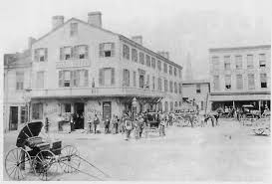

Lyddie watched as Luke and his [stagecoach](http://bookbuilder.cast.org/view_glossary.php?book=110033&word=85101#curr)  pulled away.  Then, Lyddie started looking at the [tavern](http://bookbuilder.cast.org/view_glossary.php?book=110033&word=85100#curr) .  It was huge and way more beautiful than even the Stevens' farm.  But, even though it looked beautiful, Lyddie was full of [dread](http://bookbuilder.cast.org/view_glossary.php?book=110033&word=85097#curr) .  She knew as soon as she went into the tavern she was no longer free and that she was no better than a [slave](http://bookbuilder.cast.org/view_glossary.php?book=110033&word=85098#curr) .  Lyddie began [daydreaming](http://bookbuilder.cast.org/view_glossary.php?book=110033&word=85099#curr)  of times when she was in charge of her own farm and was free living with Charlie.

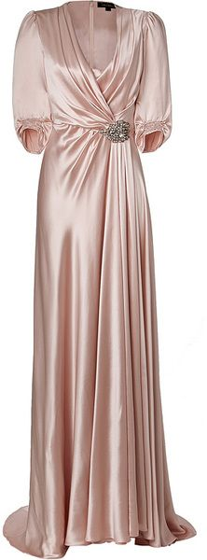

All of a sudden, Lyddie was woken from her daydream by a stagecoach coming straight towards her.  Lyddie jumped out of the way just in time.  Lyddie watched the stagecoach let out its passengers from the distance and she saw a beautiful woman wearing a pink [silk](http://bookbuilder.cast.org/view_glossary.php?book=110033&word=85103#curr)  dress.  Lyddie had never seen silk in her life as it was so [expensive](http://bookbuilder.cast.org/view_glossary.php?book=110033&word=85102#curr) .  Lyddie knew this woman must be rich.



After the lady in pink went inside a woman who worked at the tavern came outside.  She looked Lyddie up and down and, thinking she was a begger or a homeless girl because of how dirty Lyddie looked and the way she was dressed, asked Lyddie to leave the tavern.  Lyddie was embarassed, but told the woman she had been sent to work there by her mother. The woman gives Lyddie another look and realizing she is the new girl she has hired, sends her into the kitchen to find a woman named Triphena.

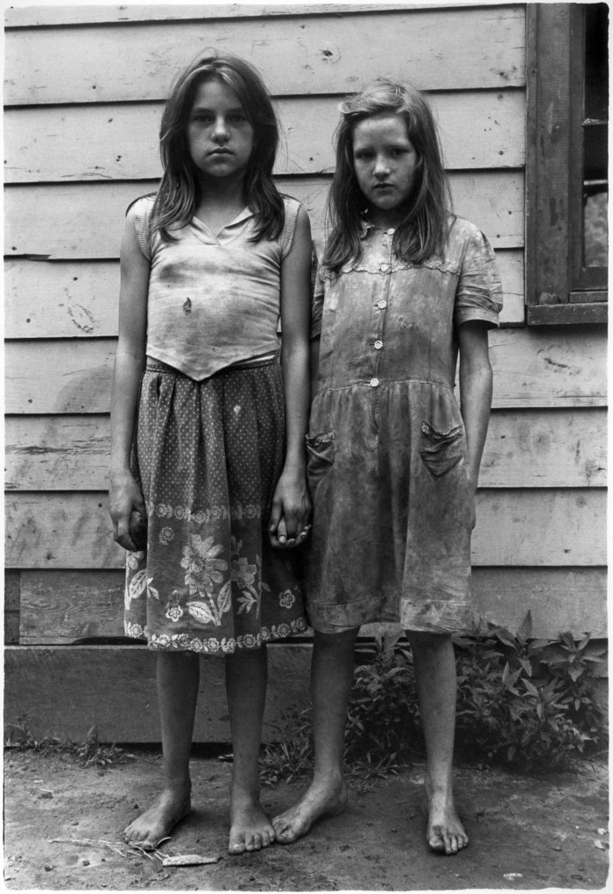

Lyddie entered the tavern and saw that the kitchen was huge.  It was almost three times the size of her family's entire cabin.  Lyddie sat in the corner while Triphena [prepared](http://bookbuilder.cast.org/view_glossary.php?book=110033&word=85104#curr) dinner for the tavern's guests.  Lyddie was happy to be ignored at that moment as she sat thinking about how old and[tattered](http://bookbuilder.cast.org/view_glossary.php?book=110033&word=85105#curr) her dresses were and how she never had time to sew new ones because she had taken on so much [responsibility](http://bookbuilder.cast.org/view_glossary.php?book=110033&word=85106#curr) at the farm.

Just then, Mistress Cutler, the woman who had hired Lyddie, came and gave Lyddie a new dress and a pair of boots to wear.  Although Lyddie was happy for the new clothes, she knew they were [a symbol of her servitude.](http://bookbuilder.cast.org/view_glossary.php?book=110033&word=85107#curr)



Lyddie missed Charlie as she worked very hard for Mistress Cutler at the tavern.

It was September and Lyddie had been working at the tavern for a few weeks now.  One day, Lyddie saw that the woman in pink silk had come back.  Lyddie overheard her talking about how she worked at a [factory](http://bookbuilder.cast.org/view_glossary.php?book=110033&word=85108#curr)  in [Lowell, Massachusetts](http://bookbuilder.cast.org/view_glossary.php?book=110033&word=85109#curr) .

When the woman recognized Lyddie she said to her "you're a good worker.  I can see that you'd do well in the mill you know..you'd clear at least two dollars a week and be independent".  Lyddie was amazed! She never thought that it was possible for a woman could make so much money.